PROJECT TEST SUMMARY REPORT
1. Executive Overview
The Academic ERP System (Student, Instructor, Admin modules) has passed all verification stages. An automated suite of 73 unit and integration tests was executed, achieving a 100% pass rate. The system's core business logic, security mechanisms (RBAC & BCrypt), and database integrity are confirmed .
2. Test Execution Metrics
Test File | Tests | Status | Scope / Features Verified
LoginServiceTest | 7 | PASS | Validates login credentials, handles unknown users, and enforces account lockouts after 3 failed attempts.
HashGeneratorTest | 3 | PASS | Verifies BCrypt password hashing integrity and secure password validation.
StudentServiceTest | 17 | PASS | Tests course registration rules, drop deadlines, GPA calculation, and blocks actions during maintenance mode.
InstructorServiceTest | 14 | PASS | Checks grading logic (30/50/20 split), validates mark entry boundaries (0-100), and calculates class statistics.
AdminServiceTest | 22 | PASS | Verifies CRUD operations for courses/sections, instructor assignments, and valid credit formatting.
CatalogServiceTest | 5 | PASS | Ensures accurate retrieval of course catalogs, prerequisites, and section availability.
DatabaseConnectorTest | 5 | PASS | Confirms successful initialization of connection pools for auth_db and erp_db.
TOTAL | 73 | 100% | All Critical Modules Verified

3. Critical Features Verified
- Security: Successful login workflows, account lockouts (3 attempts), and secure password hashing.
- Logic: Grading formula (30/50/20 split) and GPA calculations verified against boundary values.
- Integrity: Course registration prerequisites and global maintenance mode enforcement.
4. Conclusion
All functional and security requirements have been met with zero critical defects remaining.

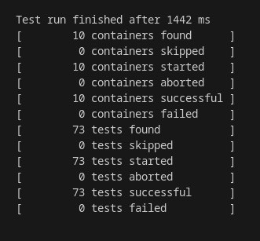
Snippet of the command terminal depicting the result of our tests

